

fundamental of computer programming

Lab 04



hanan majeed

519166

**Task A:**

Write a program that gets an integer from the user and prints whether it is an odd or even.

Input:

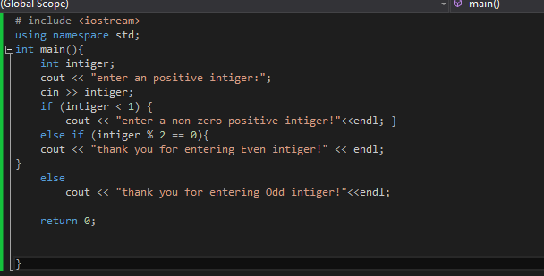

Output:

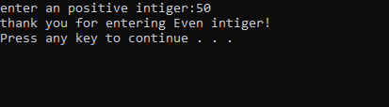

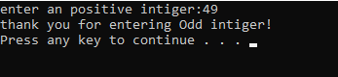

**Task B:**

Write a program that gets three different integers from a user, and then prints the smallest and the largest of these numbers.

Input:

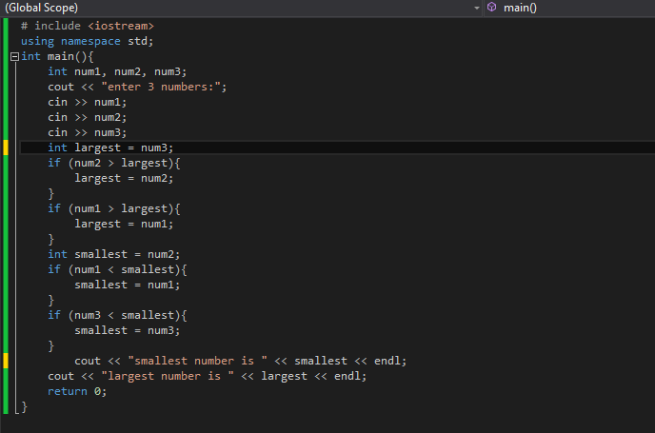

Output:

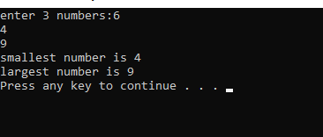

**Task C:**

Write a program that reads three nonzero integers and determines and prints if they could be the sides of a right-angled triangle.

**Hint**: Pythagoras' Theorem states that in a right-angled triangle, the square of the hypotenuse is equal to the sum of the squares of the other two sides.

Input:

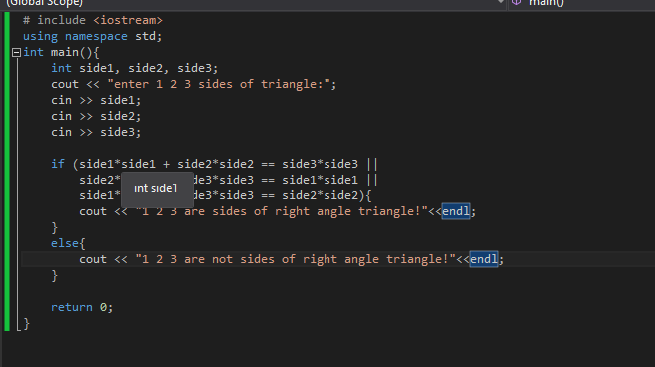

Output:

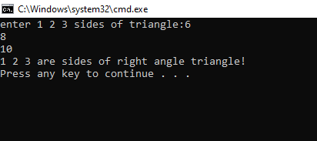

**Task D:**

Write a program that reads the year entered by a user and displays if the year entered is a leap year or not. A year divisible by 4 is a leap year but if it is divisible by 100 then it is not a leap year unless it is divisible by 400 in which case it is a leap year.

Input:

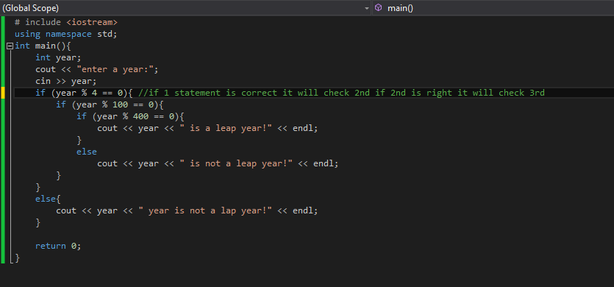

Output:

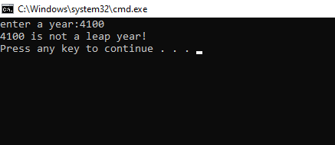

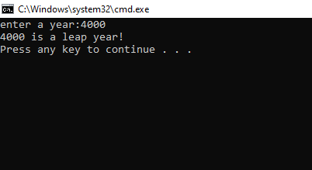

**Task E:**

A school has the following rules for the grading system:

* 80 & above: A
* 60 to 79: B
* 50 to 59: C
* 40 to 49: D
* Below 40: F

Ask the user to enter marks and print the corresponding grade.

Note: you must use **switch** statement instead of if-else-if ladder.

Input:

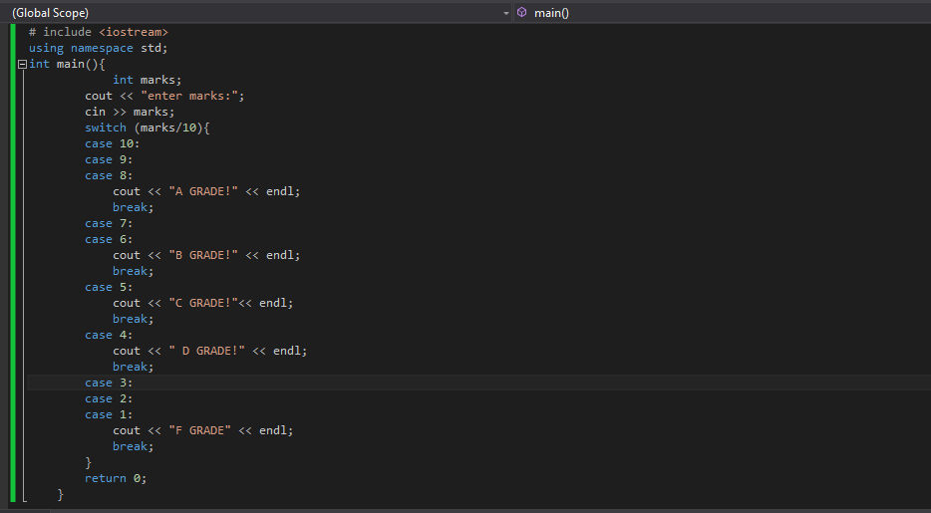

Output:

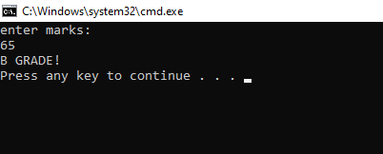

**Task F:**

To determine whether a person is overweight or obese, one can use a measure called the body mass index (BMI). The formula for BMI is

$$BMI= \frac{weight (kg)}{height*height (meters)}$$

Create a BMI calculator application that reads the user’s weight in kg and height in meters. Calculate and display the user’s body mass index. Also, the application should inform the user about his or her status based on the following ranges:

|  |  |
| --- | --- |
| **Status** | **BMI Range** |
| Underweight | Less than 18.5 |
| Normal | 18.5 to 24.9 |
| Overweight | 25 to 29.9 |
| Obese | 30 or greater |
|  |  |

Input:

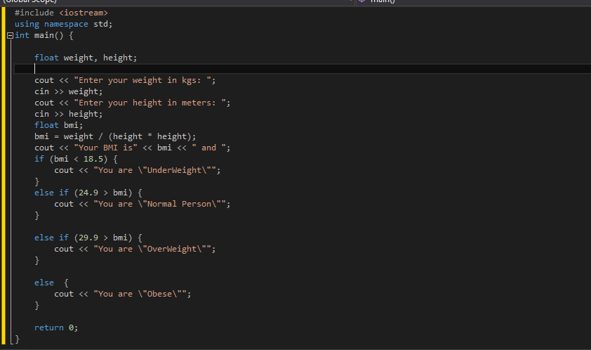

Output:

Under weight

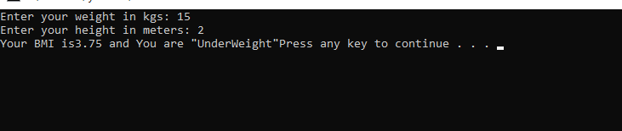

Normal

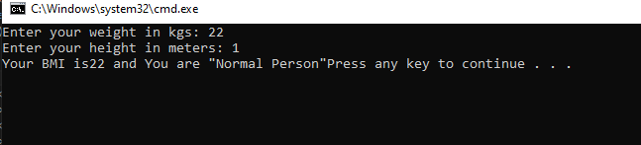

Over weight

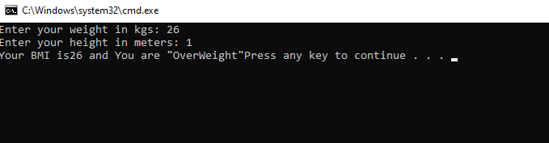

obese

